**NAANMUTHALVAN**

**ARTIFICIAL INTELLIGENCE**

**PROJECT TITLE**

**MARKET BASKET INSIGHTS**

**REG.NO :** 622521104023

**NAME :** KAVINKUMAR Y

**DEPT :** COMPUTER SCIENCE AND ENGINEERING

**YEAR & SEM :** III & 05

**COLLEGE :** SELVAM COLLEGE OF TECHNOLOGY

PHASE 1

PROBLEM DEFINITION AND

DESIGN THINKING

PROBLEM DEFINITION

* Market Basket Analysis (MBA) is a powerful data mining technique that plays a pivotal role in understanding consumer behavior and optimizing business strategies. This abstract provides an overview of the significance, methodology, and applications of MBA in contemporary retail and e-commerce settings.
* Market Basket Analysis has evolved into an indispensable tool for businesses seeking to gain a competitive edge in today's data-driven marketplace. This abstract serves as an entry point for researchers, practitioners, and business professionals interested in the fundamentals and applications of MBA, emphasizing its role in shaping the future of retail and e-commerce.

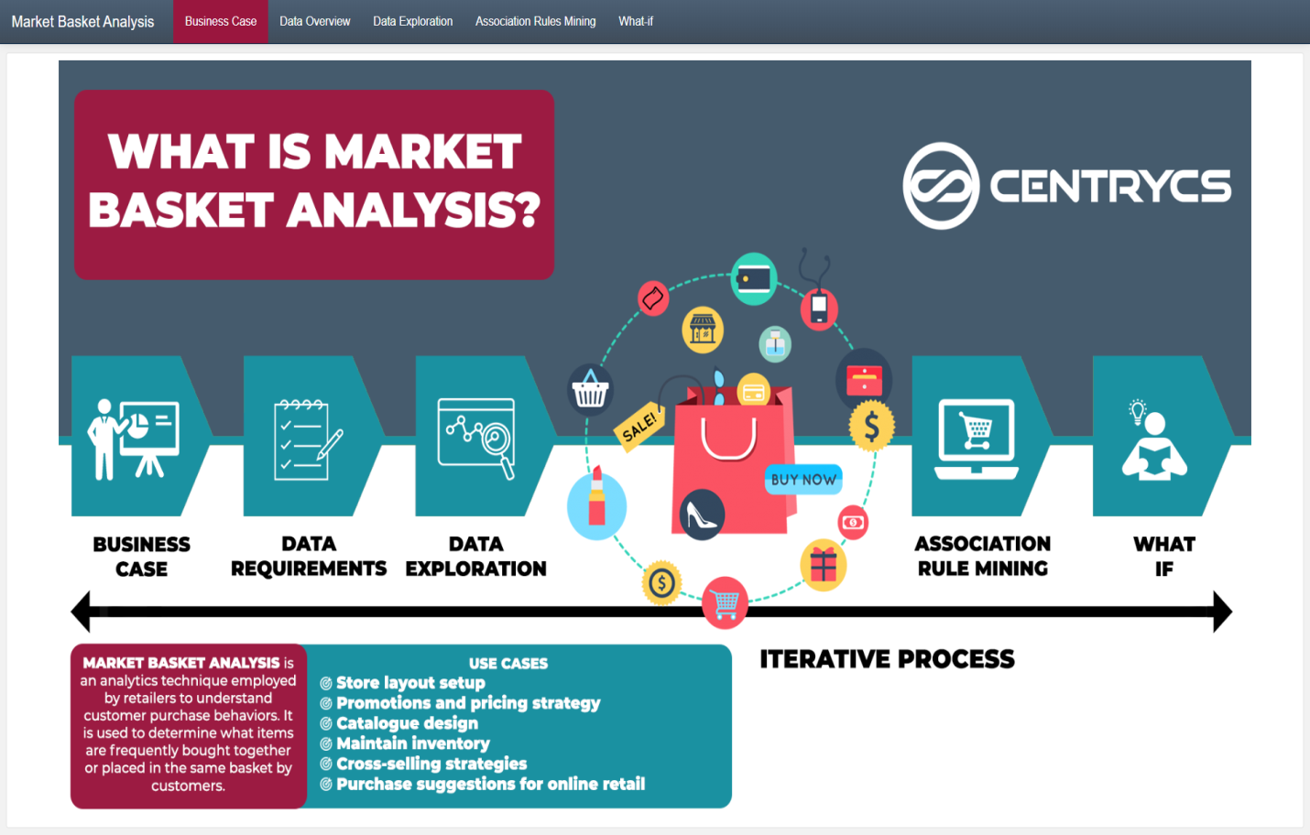

DESIGN THINKING

1. Data Source
2. Data Preprocessing
3. Association Analysis
4. Insights Generation
5. Visualization
6. Business Recommendations

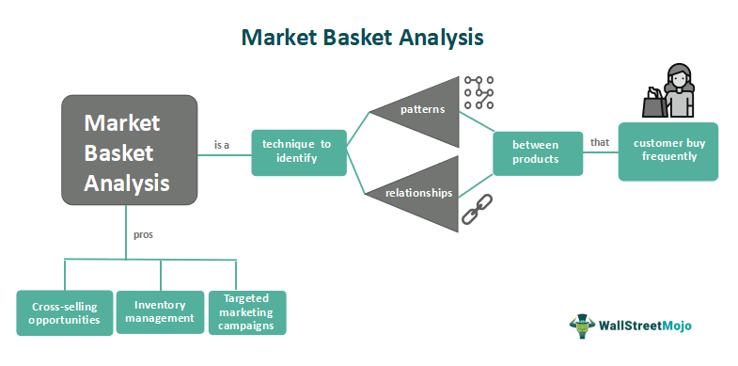

DATA SOURCE

Market basket analysis typically relies on transactional data from retail stores, e-commerce websites, or any other business where customers make purchases. The primary data source for market basket analysis is a transactional dataset that records the items purchased together by customers during their shopping trips.

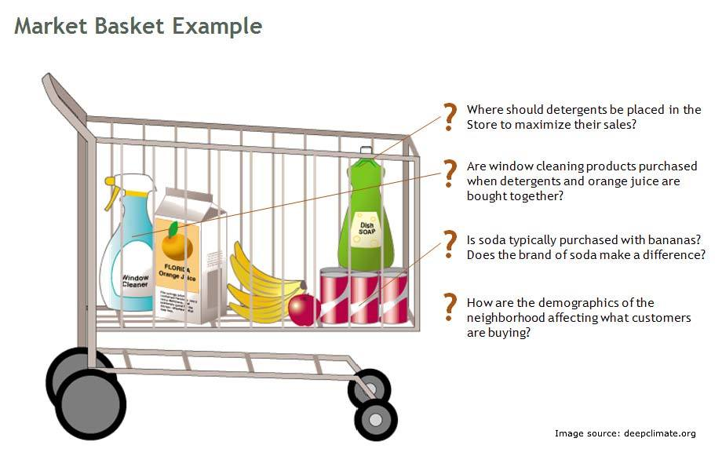

DATA PREPROCESSING

Data preprocessing is a crucial step in preparing your data for market basket analysis. It involves cleaning, transforming, and organizing your transactional data to make it suitable for analysis.

**CLEANING**



**TRANSFORMING**



**ANALYSIS**



ASSOCIATION ANALYSIS

* Association analysis, also known as Market Basket Analysis (MBA), is a data mining technique used to uncover hidden patterns, correlations, and associations between items that are frequently purchased together in transactional data.
* This method plays a crucial role in understanding consumer behavior and making informed business decisions. Here, we provide an overview of association analysis and its relevance in retail and e-commerce settings.
* Association analysis, or Market Basket Analysis, is a valuable tool for businesses to uncover hidden relationships in transactional data. By understanding the associations between products, companies can make data-driven decisions to enhance customer satisfaction, streamline operations, and drive profitability in both physical and online retail environments.



INSIGHTS GENERATION

Analyze the generated association rules to extract insights:

* **High-Confidence Rules:** Identify rules with high confidence, as they represent strong associations between items.
* **High-Lift Rules:** Look for rules with high lift, indicating that the items in the antecedent and consequent are more likely to be purchased together than independently.
* **Market Basket Insights:** Determine which items tend to be bought together frequently. For example, if customers frequently purchase peanut butter and jelly together, it could lead to insights about product placement or promotions.
* **Cross-Selling Opportunities:** Identify opportunities for cross-selling by finding rules that suggest complementary products. For instance, if customers who buy smartphones also buy phone cases, this insight can inform marketing strategies.
* **Basket Analysis Over Time:** Analyze trends in item associations over time to adapt strategies to changing customer preferences.



VISUALISATION

* Visualizations are a powerful way to convey insights derived from Market Basket Analysis (MBA). They can help stakeholders quickly understand patterns and relationships between items in transactional data.
* Develop visualization (Graphs, Charts) to present the Market Basket Analysis



BUSINESS RECOMMENDATIONS

* Market Basket Analysis (MBA) provides valuable insights into customer purchasing patterns, and these insights can be leveraged to make data-driven business recommendations.
* This type of market basket analysis involves grouping similar items or transactions into clusters or segments based on their attributes. It helps to identify customer segments with similar purchasing behaviors, which can inform product recommendations and marketing strategies.

